UNSTABLE CERVICAL SPINE
DR.K.MURUGESAN MDDA
ASSOCIATE PROFESSOR, ANAESTHESIOLOGY,
G.M.K.MEDICAL COLLEGE, SALEM

INTRODUCTION
The cervical spine gives stability and protection to the neural elements, despite of the high degree of flexibility. This is due to an interaction of the bony, ligamentous and muscular elements.
Disturbance of the normal anatomy can lead to imbalance and instability. When this will be left uncorrected, it may progress to significant deformations of the cervical spine.
The cervical spine is crucial for normal load distribution.

ANATOMY OF CERVICAL SPINES

Clinically Relevant Anatomy

The cervical spine is made up of 7 vertebrae.
The atlas(C1) and axis(C2) are specialized to allow a greater range of motion than normal vertebrae. They are responsible for the nodding and rotation movements of the head.The atlanto-occipital joint allows the head to nod up and down on the vertebral column. The dens acts as a pivot that allows the atlas and attached head to rotate on the axis, side to side..
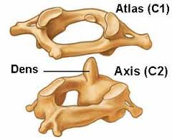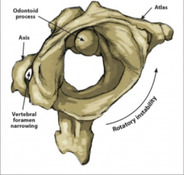

The atlas and axis are important neurologically because the brain stem extends down to the axis.
Approximately 50% of flexion extension of the neck happens between the occiput and C1(atlanto-occipital joint) ; 50% of the rotation of the neck happens between C1 and C2 (atlantoaxial joint).
The cervical spine is much more mobile than the thoracic or lumbar regions of the spine. Unlike the other parts of the spine, the cervical spine has transverse foramina in each vertebra for the vertebral arteries that supply blood to the brain.
The craniocervical junction (atlanto-occipital joint), the lower atlanto-axial joint and other cervical segments are reinforced by internal as well as external ligaments. They secure the spinal stability of the cervical spine as a whole, together with surrounding postural muscles and allow cervical motion. They also provide proprioceptive information throughout the spinal nerve system to the brain.
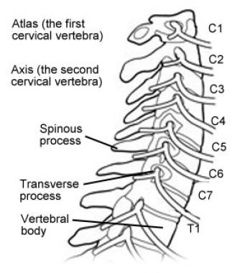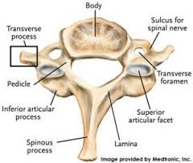

Ligaments
Although the cervical spine consists of 7 cervical vertebrae interspaced by intervertebral disks, the complex ligamentous network keep the individual bony elements behaving as if they were a single unit.
As noted, the cervical spine can be viewed as being made up of anterior and posterior columns. It can also be useful to think in terms of a third (middle) column, as follows:
- The anterior column consists of the anterior longitudinal ligament and the anterior two thirds of the vertebral bodies, the annulus fibrosus and the intervertebral disks
- The middle column is composed of the posterior longitudinal ligament and the posterior one third of the vertebral bodies, the annulus fibrosus, and the intervertebral disks
- The posterior column is made up of the posterior arches, including the pedicles, transverse processes, articulating facets, laminae and spinous processes
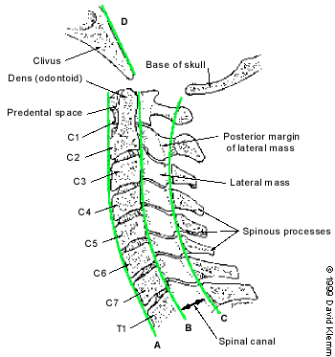
The longitudinal ligaments are vital for maintaining the integrity of the spinal column. Whereas the anterior and posterior longitudinal ligaments maintain the structural integrity of the anterior and middle columns, the posterior column alignment is stabilized by a complex of ligaments, including the nuchal and capsular ligaments and the ligamentum flavum.
If 1 of the 3 columns is disrupted as a result of trauma, stability is provided by the other 2, and cord injury is usually prevented. With disruption of 2 columns, spinal cord injury is more likely because the spine may then move as separate units. The transverse ligament is the most important ligament for preventing abnormal anterior translation.
Causes of cervical deformity/ instability
- Congenital and developmental cervical deformities (The atlanto-axial instability in down’s syndrome)
- Neoplastic cervical deformities
- Neurologic abnormalities
- Metabolic and degenerative cervical deformities Cervical instability is often diagnosed in patients with rheumatoid arthritis, due to the progressive destruction of the cervical skeletal structures. The most affected region is the suboccipital region and another regions of the cervical spine C4-C5
- Inflammatory- induced cervical deformities
- Infection- induced cervical deformities
- Iatrogenically induced cervical deformities
- Traumatically induced deformities
cervical instability can also be a cause of delayed or missed diagnosis of cervical spine injury occured after trauma(car accident, high impact on the neck)

RISK FACTORS
The following risk factors are associated with the potential for bony or ligamentous compromise of the upper cervical spine
- History of trauma (e.g. whiplash, rugby neck injury)
- Throat infection
- Congenital collagenous compromise (e.g. syndromes: Down’s, Ehlers-Danlos, Grisel, Morquio)
- Inflammatory arthritides (e.g. rheumatoid arthritis, ankylosing spondylitis)
- Recent neck/head/dental surgery.
- Risk factors for development of instability -> Factors that appear to postoperative deformity
- Younger age
- Lack of pre-operative lordosis
- Disruption of the facet joints
- Age
♣Youth (risk taking behaviour)
♣Older adults (age related degeneration and falls)
- Gender: males more than females
- Alcohol or drug use
- Motor vehicle collision
There are many types of cervical spine fracture, some of which are unstable; general indicators of instability include:
- more than one vertebral column involvement
- increased or reduced intervertebral disc space height
- increased interspinous distance
- facet joint widening
- vertebral compression greater than 25%
Some fractures are associated with blunt cerebrovascular injury (BCVI) such as high (C1-C3) fractures, those associated with subluxation and of course, those fractures involving the transverse foramen.
PRESENTATION
It is generally accepted that cervical instability is caused by trauma (one major trauma or repetitive microtrauma), rheumatoid arthritis or a tumor. In cases associated with trauma, head and facial injuries may be present. The flexion-extension movement exerted on the spine can cause ligamentous disruption with subsequent atlantoaxial instability (AAI) also known as upper cervical instability. Upper cervical spine instability is associated with inflammatory conditions such as RA and ankylosing spondylitis. Trauma and congenital deviation (eg, down syndrome) also can cause upper cervical spine instability. Usually, persons with congenital anomalies do not become symptomatic before midlife adulthood. The spine is assumed to be able to accommodate differing regions of hypermobility and fusions. With time, the degenerative changes occurring in the lower cervical spine increase rigidity and alter the balance.
This gradual loss of motion places increasing loads on the atlantoaxial articulation
Symptoms can be different but the most frequent clinical findings are:
• Neck pain with sustained postures
• Weakness of the neck
• Altered ROM
• Hypermobility and soft end-feeling in passive therapies(tenderness)
• Poor cervical muscle strength (multifidus, longus capitis, longus colli)
• Referred pain in the shoulder and parascular area
• Cervical radiculopathy
• Cervical myelopathy
• Occipital and frontal or retro-orbital headaches
• Paraspinal muscle spasm
• Decreased cervical lordosis
DIAGNOSIS
CLINICAL DIAGNOSIS
Cervical instability is a diagnosis based primarily on a patient’s history (ie, symptoms) and physical examination because there is yet to be standardized functional X-rays or imaging able to diagnose cervical instability or detect ruptured ligamentous tissue without the presence of bony lesions.
Radiologically, instability is checked by criteria given by White and Punjabi which is as follows
- Destruction or loss of function of anterior elements
- Destruction or loss of function of posterior elements
- Relative translation of vertebra in sagittal plane > 3.5 mm
- Angulation of one vertebra to another > 11 mm
- Positive stretch test for cervical spine.
- Damage to the cord
- Nerve root damage
- Abnormal narrowing of disc space
- Dangerous loading anticipated
Except for last three points, each point is given a score of 2. Last three points are given score of 1.
A positive score of more than 5 indicates instability.
Following xrays show an example of instability.
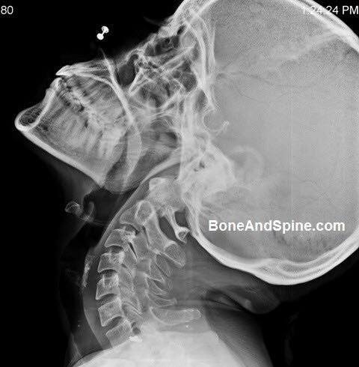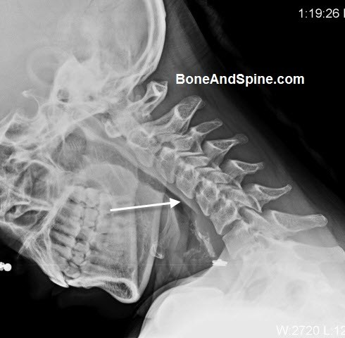
The xrays above are of 38 years old lady who suffered from chronic neck pain. Her routine xray of cervical spine revealed a kyphotic deformity at C4-C5 level. Flexion and extension views were done. While the deformity got corrected in extension view, it got exaggerated in flexion suggesting dynamic cervical spine instability.
functional computerized tomography (fCT) and magnetic resonance imaging (fMRI) scans and digital motion x-ray (DMX) are able to adequately depict cervical instability pathology

MANAGEMENT

The role of anaesthetist
a) As a team leader or member in prehospital management
b) The anaesthetist may need to secure an airway in a patient with an unstable cervical spine for resuscitation or for subsequent surgery, including on other trauma injuries.
c) Management of patient in icu

As a team leader or member in prehospital management

*Cervical spinal precautions should be instituted immediately on suspicion of unstable cervical spine to immobilise the cervical spine above and below the suspected level of injury,preventing flexion, extension, lateral rotation and lateral flexion.
*All patients with major trauma should be considered to have a potential cervical spine injury unless proven otherwise.
* Care must start at scene of injury to reduce injury and preserve function.
* It involves rapid assessment of ABC (airway, breathing, circulation). Immobilize and stabilize head and neck, use cervical collar before moving onto backboard.
*A well-fitting semirigid cervical collar is adequate until imaging can be conducted.
*If a cervical collar is not available, the patient can be placed in a neutral supine position on a rigid surface (spine board if available) and the head immobilised with sandbags or rolled towels and tape until paramedic assistance arrives.
*Ambulance services generally use a single piece, rigid short term collar (eg. Stifneck: Laerdal Medical Corporation, New York, USA) which is useful for cervical spine. Stabilization during transfer to hospital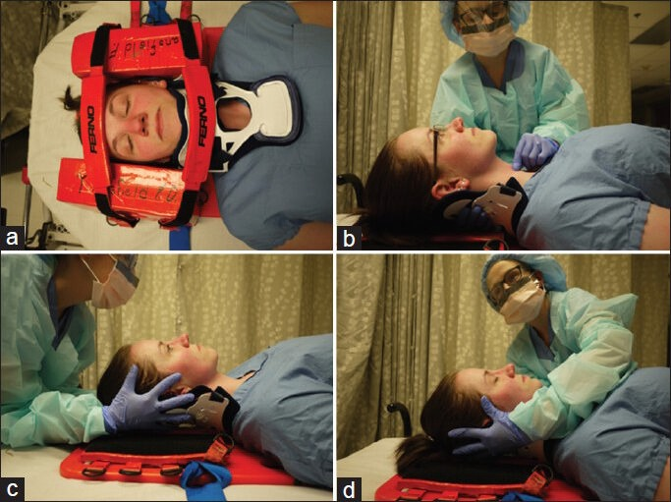

*In patients without radiographic evidence of injury, gradual return to a full range of movement and early return to normal daily activities are recommended.
• Injuries at C1 –C4 may result in respiratory paralysis but advances in trauma care allow patients to survive with ventilator assistance.
• The C-spine of awake and alert patients may be cleared by history of a low risk mechanism and normal physical examination (using the Nexus criteria or Canadian C-spine rule).
• Given the probability of head injury or other significant trauma this is not always possible. For these patients, a multi-slice CT scan should be performed, this is most practical
At the same point as a CT head. Scanning should be from occipital to T1 and allow Sagittal and coronal reconstruction to exclude ligament us instability. This should be soon as practically possible, and is advisable within 72 hours. .

Airway Management
• It is advisable to perform a detailed assessment of the neurological deficit before intubation
• The basic principle is to maintain a patent airway whilst minimising any potential risk to the cervical spine.
• Every patient with a suspected cervical injury should be considered a potential difficult airway, due to:
- Inability to achieve optimal positioning because of inline manual stabilisation or collar
- Presence of blood, secretions or oedema secondary to the initial injury.

Cervical spine movement during intubation
With the anatomic proximity of airway structures to the cervical spine, it follows that the spine and spinal cord can be significantly displaced during airway intervention and positioning. Sniffing position, traditionally used during tracheal intubation, involves near-full extension of the atlanto-occipito and atlanto-axial joints and flexion of the lower cervical spine.

• The main choice for the anaesthetist is
- awake fibreoptic intubation (FOI)
- intubation by direct laryngoscopy with inline manual stabilisation (or asleep FOI)
- intubation by video laryngoscope
- Laryngeal mask airway
• Awake FOI should only be attempted by an experienced practitioner and is not advisable in situations where a patient cannot be co-operative (for example–intoxication or head injury).
- Careful use of sedation and appropriate use of local anaesthetics can smooth the process and minimize any sympathetic response.
- An acceptable dose of lignocaine is as high as 9mg/kg, given the small amount of systemic absorption.
- This may be combined with cautious use of sedation.
- Awake FOI allows the anaesthetist to assess neurology after intubation and prior to surgery.
• Direct laryngoscopy should use a minimum amount of force.
- Many advocate the use of a bougie to minimise the force required. Some
studies have suggested no significant increase in complications, hypoxia or time to intubation with bougie use.
Video laryngoscopes may improve the view at laryngoscopy. This may require less force to obtain the view, although should only be used by those experienced in its practice in this situation.
- The use of cricoid pressure to minimise passive regurgitation of gastric contents may be necessary in unfasted patients but it may worsen intubating conditions and may possibly worsen C-spine instability.Suction should be on and readily accessible.
- inline manual stabilisation keeping in place the posterior part of the collar to reduce risk of movement is recommended

Laryngeal mask airway
*Laryngeal mask airways (LMAs) remain controversial for airway management of patients with known or suspected cervical spine injury, as some studies have shown increased cervical spine displacement relative to intubation and other studies have shown no significant
*In addition to providing ventilation in a potentially disastrous cannot intubate and cannot ventilate scenario, LMAs can often be used to facilitate tracheal intubation. LMA may be associated with a shorter intubation time and less mucosal damage in patients with an immobilized cervical spine.
*The Fastrach LMA system has also been validated for use in difficult airway scenarios including cervical spine immobilization. Regardless of the device used, LMAs remain an essential tool in the difficult airway algorithm for all patients, including those with trauma and cervical spine injury.
Conduct of Anaesthesia
Anaesthetic management
Anaesthetic concerns in patients with spinal injuries at various time points are as follows:
Acute phase (0-48 h)
- Spinal shock with hypotension, bradycardia and poor response to any stimulus
- Relative or absolute hypovolemia requiring a careful combination of volume replacement and inotropic support under central venous pressure monitoring
- Full stomach necessitating "Crash-induction" with Sellicks' manoeuvre for intubation
- Other concomitant injuries, especially those involving long bones, abdomen and thorax
Semi-acute phase (48 h to a variable period ranging from 1 to 12 weeks)
- Persistent spinal shock in some patients
- Risk of hyperkalemia from succinyl choline (Development of extra-junctional acetylcholine receptors)
- Risk of hypercalcemia
Intermediate phase (1-12 wks)
- Spinal shock resolved
- Autonomic hyper-reflexia
- Risk of hyperkalemia from succinyl choline
- Risk of hypercalcemia
Chronic phase (> 3 months)
- Risk of hyperkalemia from succinyl choline up to 8-12 months post injury
- Autonomic hyper-reflexia
- Hypercalcemia
- Contractures
- Osteoporosis
Preanaesthetic evaluation
Neurological assessment
A standardised neurological assessment of patients with spinal injuries, as proposed by the American Spinal Injury Association (ASIA), consists of: (a) Muscle testing (b) Sensory testing and (c) Assessment of completeness of injury.
Anaesthesia for surgical procedures
Securing the airway is the most crucial step during the anaesthetic management of a patient with cervical spine injury.
Assessment of cervical spinal stability prior to airway maneuvers
Despite liberal use of cervical spine x-rays in trauma, the majority of them are normal. In order to avoid unwanted radiographs, five clinical criteria have been used to clear cervical spine in conscious trauma patients . These criteria are: a) no posterior midline cervical spine tenderness, (b) no intoxication, (c) alert patient, (d) no focal neurological deficits and (e) no painful distracting injuries. The overall sensitivity of these criteria for identification of any type of cervical spine injury is 97.6% and 99% for significant injury. The criteria, however, have a low specificity. Conscious patients who do not satisfy the above criteria must be investigated cervical radiography. In patients with altered mental status, there is no consensus on the criteria for cervical spine clearance. It is a common practice to rule out injury to cervical spine by a lateral radiograph.
Depending on the needs of the individual surgery, and the condition of the patient, there are three options of anaesthesia:
- Standby, local anaesthesia and sedation
- General anaesthesia
- Regional anaesthesia
Standby, local anaesthesia and sedation
Absence of sensations below the level of the lesion enables many surgical procedures to be carried out without any form of anaesthesia subject to absence of risk factors for autonomic hyperreflexia (high level lesions, previous h/o autonomic hyperreflexia, urological procedures) and absence of frequent troublesome spasms and the patient is willing. Local anaesthetic infiltration may be required in cases of incomplete lesions. Adrenaline should be avoided in local anaesthetic solutions as these patients are sensitive to catecholamines. Sedation with benzodiazepines might decrease the risk of spasms. Presence of an anaesthetist, standard monitoring and an intravenous access are mandatory even during 'standby' procedures.
Sedative premedication is generally avoided. Oral premedication may have inadequate effect because of delayed gastric emptying. Some centres use antihypertensives such as nifedipine for premedication to prevent autonomic hyperreflexia.
Reduced distribution volume renders spinal cord injured patients sensitive to intravenous induction agents, a problem that is compounded by the absence of sympathetic reflexes. Thiopentone, propofol and all available inhalational anaesthetics have been used for general anaesthesia. Non depolarising muscle relaxants are used to facilitate intubation. Repeat doses are rarely required. Suxamethonium is generally avoided between day 3 and 9 months. Preloading the patient with about 500-1000 ml of crystalloid might decrease the incidence of hypotension at induction. Atropine must be kept handy to treat any episodes of bradycardia.
General anaesthesia with an inhalational agent and spontaneous respiration is appropriate for short procedures. Controlled ventilation has the advantage of maintaining adequate gas exchange. Impaired baroreflexes may cause hypotension during IPPV.
Quadriplegic patients poorly tolerate acute positional changes. Therefore, positioning must be done gradually. All pressure points must be adequately protected. Heat loss must be prevented by using heated humidifiers and forced air warming devices. Autonomic dysreflexia, muscular spasms and penile erection complicating urological surgery may be effectively treated by deepening the anaesthesia.
Spinal anaesthesia has been used for urological surgery in chronic spinal injuries. Reliable suppression of autonomic dysreflexia is the argument in favour of spinal anaesthesia. Technical difficulties may be encountered due to kyphoscoliosis, previous surgery and muscle spasms. Hyperbaric bupivacaine (0.5%) in a dose of 1.5-2.0 ml has been successfully used. Difficulties may be encountered in defining the level of the block unless the block has spread to above the level of the spinal lesion. Level of block may also be determined by observing the level at which the spastic paralysis becomes flaccid after administration of spinal anaesthesia. Many centres are hesitant to use spinal anaesthesia despite lack of evidence suggesting worsening of neurological outcome with spinal anaesthesia. Epidural anaesthesia is less satisfactory than spinal anaesthesia because of distortion of the epidural space and missed segments. Epidural pethidine and fentanyl have been used to control autonomic hyperreflexia.
For spine fixation

• Whilst airway management is crucial, the anaesthetist has to maintain a perfusion
pressure to the damaged cord.
• Given the possibility of altered haemodynamics, we aim for a MAP of at least 80mmHg. Invasive arterial blood pressure monitoring is mandatory for any spinal cord injury. As with other neurosurgical cases, large fluctuations in pressure are probably worse than a single brief episode.
• Ventilation should maintain PaCO2within normal range (33-35mmHg).
• Large bore IV access is required given the possibility of significant blood loss and central venous access to facilitate vasopressor infusion to manage spinal shock.
• Careful intra-operative positioning can improve surgical access and decreases the risk of venous congestion, for example from compression of the inferior venacava.
• Spinal surgery is high risk for damage to vulnerable pressure areas, particularly
the eyes.
- It is critical that the eyes are well protected with no external pressure.
- A review of those with visual loss following surgery found that obesity, male gender, Wilson frame use, increased duration and greater blood loss were all risk factors.
- We advocate the use of a skull fixation device to reduce morbidity.
• Analgesic requirements will depend on the nature of surgery –some patients will
have sensory loss below the level of injury.
- When sensation remains, operations may be particularly painful due to
the dissection of spinal muscles.
• All patients will need to go to a high dependency area post-operatively.
• The level of injury may necessitate returning the patient to an intensive care bed
prior to “waking up.” Determining whether to extubate a patient will be a “case-
by-case” decision.
- Doubt over the patient’s ability to ventilate or prolonged, extensive surgery
- significant blood loss increase the probability of postoperative ventilation.
- Approximately, a vital capacity while intubated of greater than 20ml/kg would
support early extubation.

Management of patient in icu
- Airway management:
Indications for intubation in patients with spinal cord injury are
  - acute respiratory failure,
  - decreased level of consciousness (Glasgow score <9),
  - increased respiratory rate with hypoxia, PCO₂ more than 50 mm Hg, and vital capacity less than 10 mL/kg.
  - If a lesion is present at or above C5, intubation and assisted ventilation will often be required.
- Breathing:
  - Give oxygen (hypoxia can compromise the injured cord).
  - Watch for paradoxical (diaphragmatic) breathing indicating a possible cervical injury.
- Hypotension:
  - May be due to haemorrhage or neurogenic shock in acute spinal cord injuries.
  - Haemorrhage may be due to other injuries - eg, chest, intra-abdominal, retroperitoneal, or pelvic or long bone fractures.
  - Initial treatment of spinal shock is careful fluid replacement, usually with an isotonic crystalloid solution.
- Haemodynamically significant bradycardia should be treated with atropine (pharyngeal stimulation - eg, oral suctioning - can also induce significant bradycardia).
- A urinary catheter should be inserted and the urine output monitored. Occasionally, a positive inotrope such as dopamine is required.
- Associated head injury: may require assessment with CT scan and appropriate management.
- Ileus is common. A nasogastric tube is essential. Anti-emetics should be used to prevent aspiration.
- Prevent pressure sores: regular turning of the patient, protective padding to all extensor surfaces and removal of the spinal board as soon as safe and appropriate.
- High-dose methylprednisolone steroid therapy is the only pharmacological treatment shown to be effective when given within eight hours of injury.However, the use of methylprednisolone remains controversial and only considered of marginal benefit.
- Treatment of pulmonary complications and/or injury in patients includes oxygen for all patients and appropriate treatment for pneumothorax and/or haemothorax.
- Further assessment and monitoring:
  - ECG monitoring.
  - Monitor Glasgow Coma Scale.
  - Temperature: there may be loss of thermoregulation, so keep the patient comfortably warm.
  - A thorough but rapid assessment of all major injuries is essential. Head to toe examination for other injuries, especially neurological and skeletal.
  - Full neurological examination of motor and sensory functions.
Neurogenic Shock
• Cervical spine injury, particularly transection can cause profound cardiovascular instability.
• The loss of sympathetic vasoconstriction results in venous pooling of blood, whilst absence of sympathetic cardiac input prevents a compensatory tachycardia.
• Careful fluid resuscitation and early introduction of vasopressors can help counter
hypotension.
• Invasive monitoring is mandatory and should include CVC.
Autonomic Hyper-reflexia
• In the weeks following a high spinal injury (above T6), stimulation of the autonomic nervous system can lead to profound systemic symptoms,including hypertension, tachycardia, flushing, sweating and headaches.
- A stimulus, often from the bladder or bowel, causes nerve conduction up
the spinal cord until terminated by the level of injury.
- A reflex is activated that increases activity of the sympathetic portion of
the autonomic nervous system.
- This results in spasms and vasoconstriction, which causes a rise in the blood
pressure. This is detected by the brain but due to the injury, cannot respond.
• For these patients, spinal anaesthesia may be useful although technically difficult.
• Otherwise, deep general anaesthesia reduces the risk of complications

CONCLUSION
Overall, there is no one perfect way to manage the airway in patients with potential unstable cervical spine.
*We, the anaesthesiologist, must use their judgement and weigh various risks like spinal cord injury, aspiration, and hypoxia in each patient and have the most experienced provider available to safely secure the airway.
*An airway management and anesthetic plan must be designed based on the patient, surgeon, situation urgency and individual provider's level of expertise. Anaesthesiologist have to communicate with neurosurgeons about the plan and elicit information whenever possible about the injury and types of movement that are at highest risk of secondary injury. As always, providers have to document their reasoning in the anesthesia record to protect themselves and their patients from negative consequences.
*While Anaesthesiologist remain vigilant about preventing secondary injury in patients with cervical spine injury, they must keep in mind that forces during intubation and positioning are likely to pale in comparison to the forces that caused the initial injury.
*Thankfully, with a handful of exceptions, careful airway management is not associated with causing significant neurologic deficit, so efforts to safely care for patients with the most familiar technique are worth the effort

